**University of Puthisastra**

## ICT

## Year 4 (Semester 1)

## Course: Web Development with Frame Work

## Lecturer: SO Vengleab

# Mid-Term Project

## Members:

## Chea Sopanharith (Leader)

## Thai Sereywathana

## Touch Teng

## SOFTWARE INTERFACE

This section lists the requirement that are needed to run the system efficiently. These are as follow:

Operating System: Window, Mac OS, or Linux

Browser: Chrome, Firefox, Opera, or Microsoft Edge

Integrated Development Environment: Npm, React JS

PRODUCT FUNCTION

This website would have the following basic functions:

## Login Functions (http://localhost:3000/login)

It just a static template for applying in this project

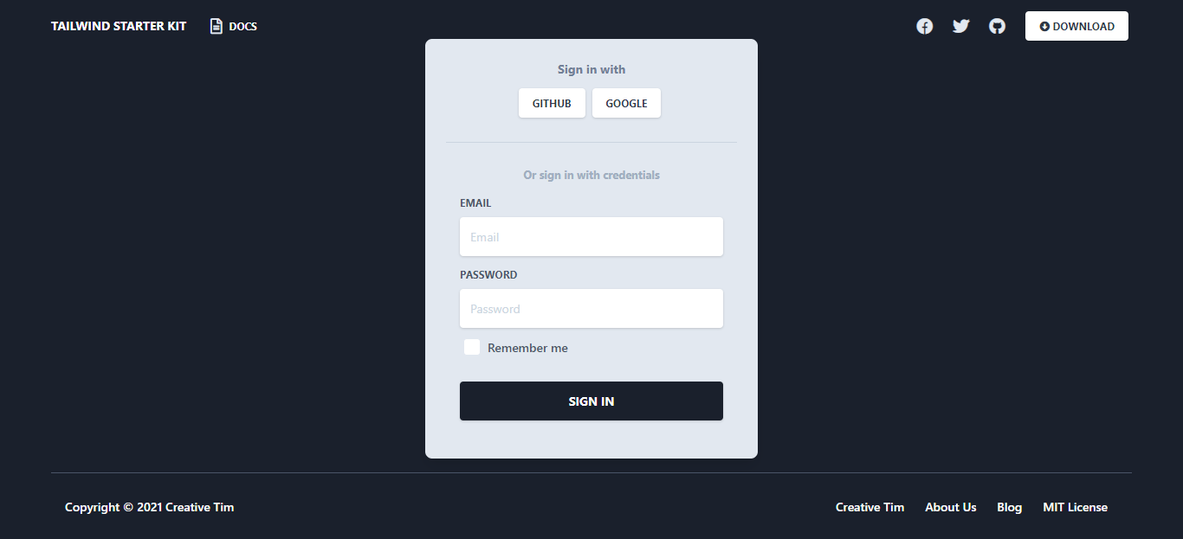

**PROFILE FUNCTION (**[**http://localhost:3000/profile**](http://localhost:3000/profile)**)**

It show the profile of user who logged in the website

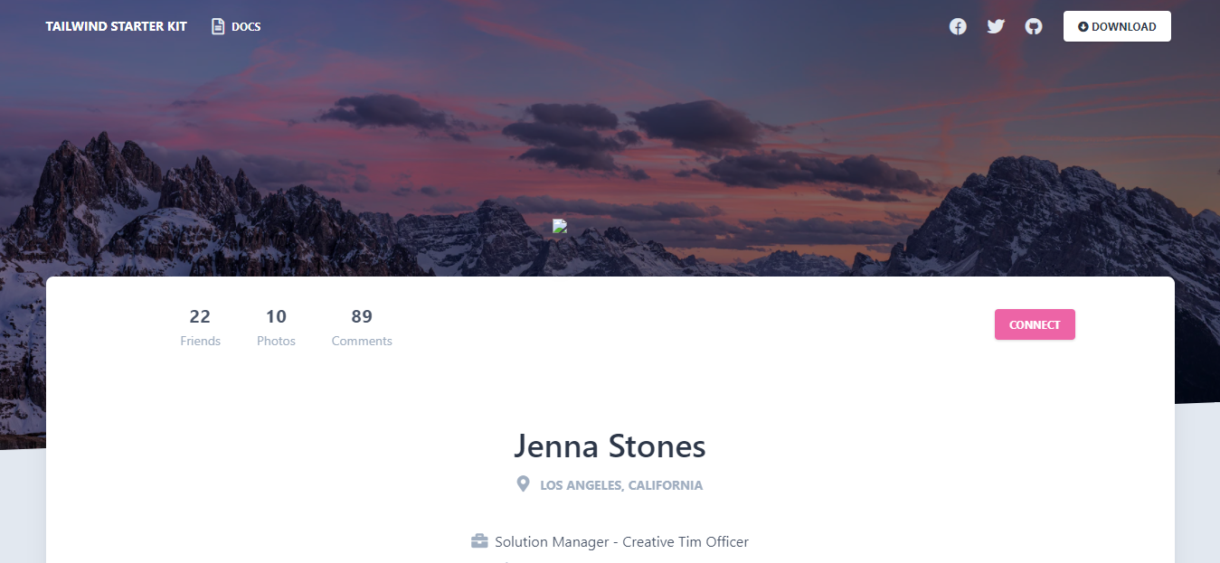

**LANDING FUNCTION (**[**http://localhost:3000/landing**](http://localhost:3000/landing)**)**

Some information is going to show in this page

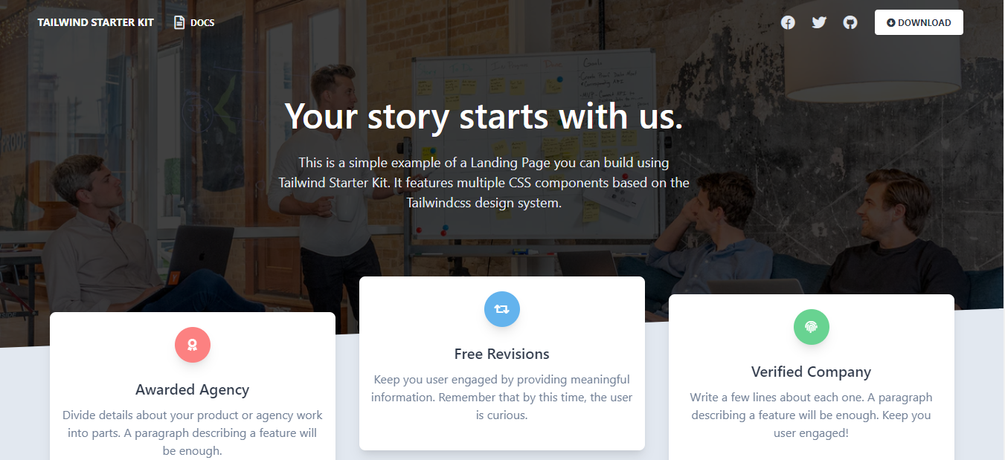

## PROJECT SETUP INSTRUCTIONS

1. Clone or download .zip

2. cd into the project

3. run the command npm install

4. npm start

## PROJECT ACTIVITIES

Chea Sopanharith

* Applied the templates in this project

Touch Teng:

* Do to Report

Thai Sereywathana

* Do the document

## CONCLUSION

This blog website is made and designed with new and easy way for user to user and browse. It features up to date content from the blogger. Also, for the administrator and owner to control much more within the whole function in hand. With any mistakes and misfunction, I would like to apologize to lecturer.

## REFERENCE

Websites:

* https://www.creative-tim.com/learning-lab/tailwind-starter-kit/presentation

Templates:

* https://www.creative-tim.com/